Ehab Kamal Soliman

Assignment 7

Recommender System

# Similarity matrix calculation

* First, I loaded the csv files into pandas DataFrame.
* 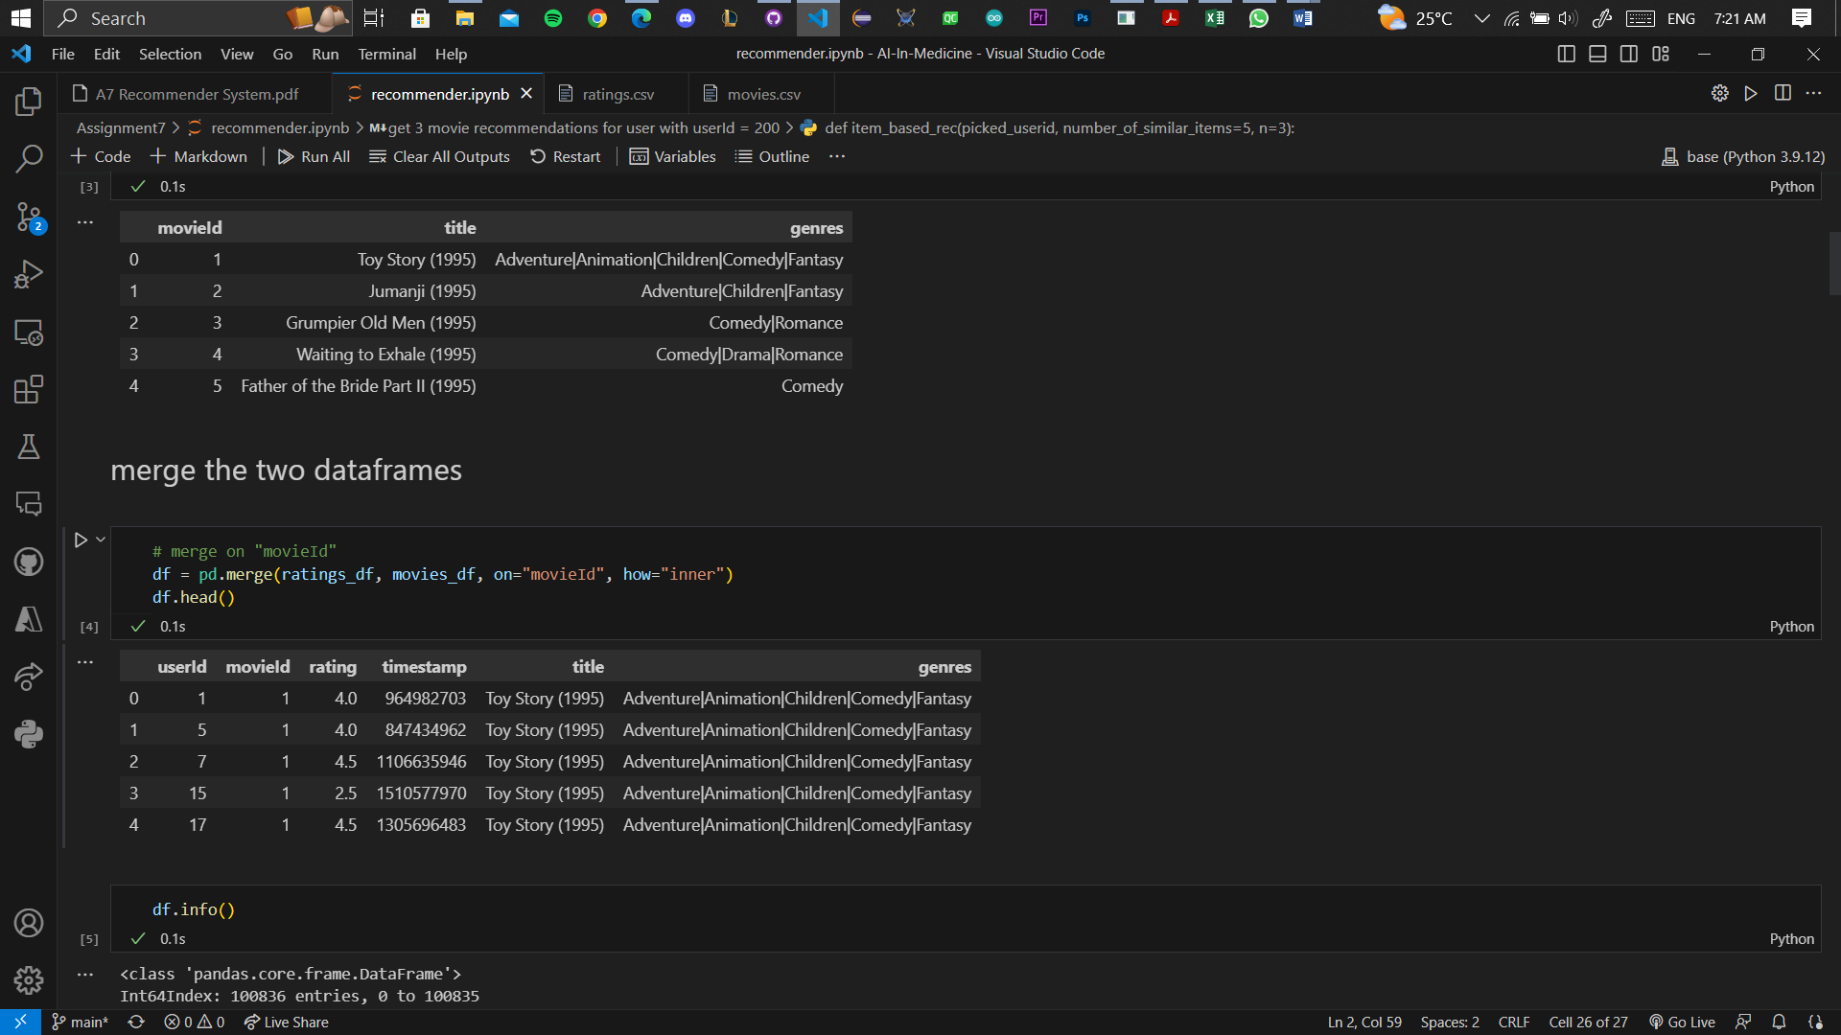I merged the two data frames on “movieId”
* I subset the data frame to have only first 200 user and 200 movies

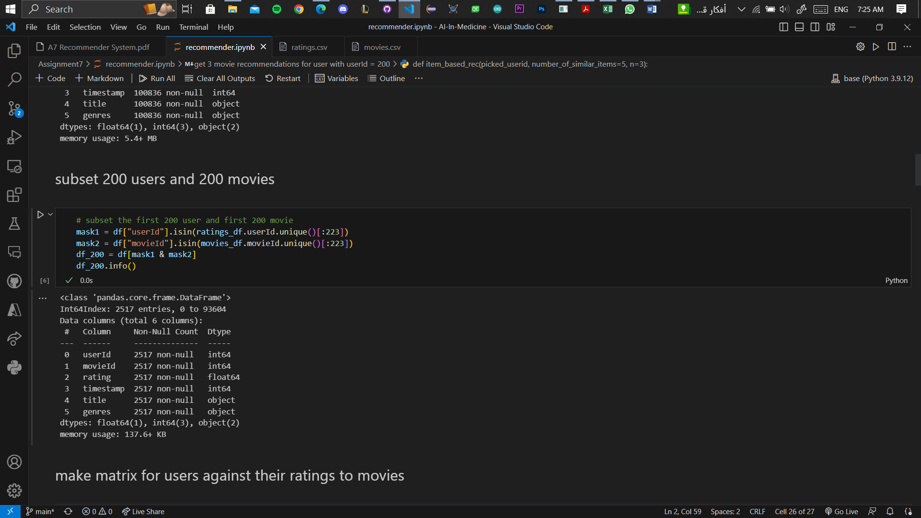

* 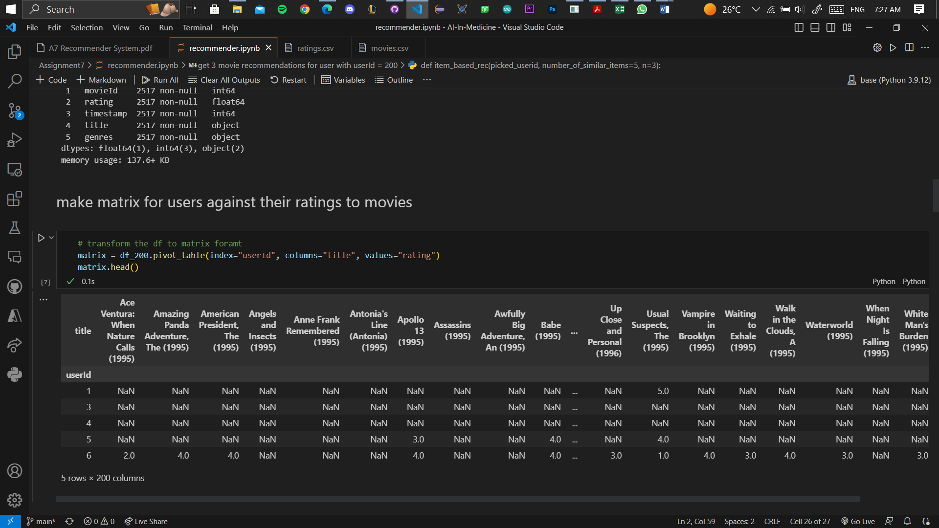I made matrix for users against their ratings to movies
* 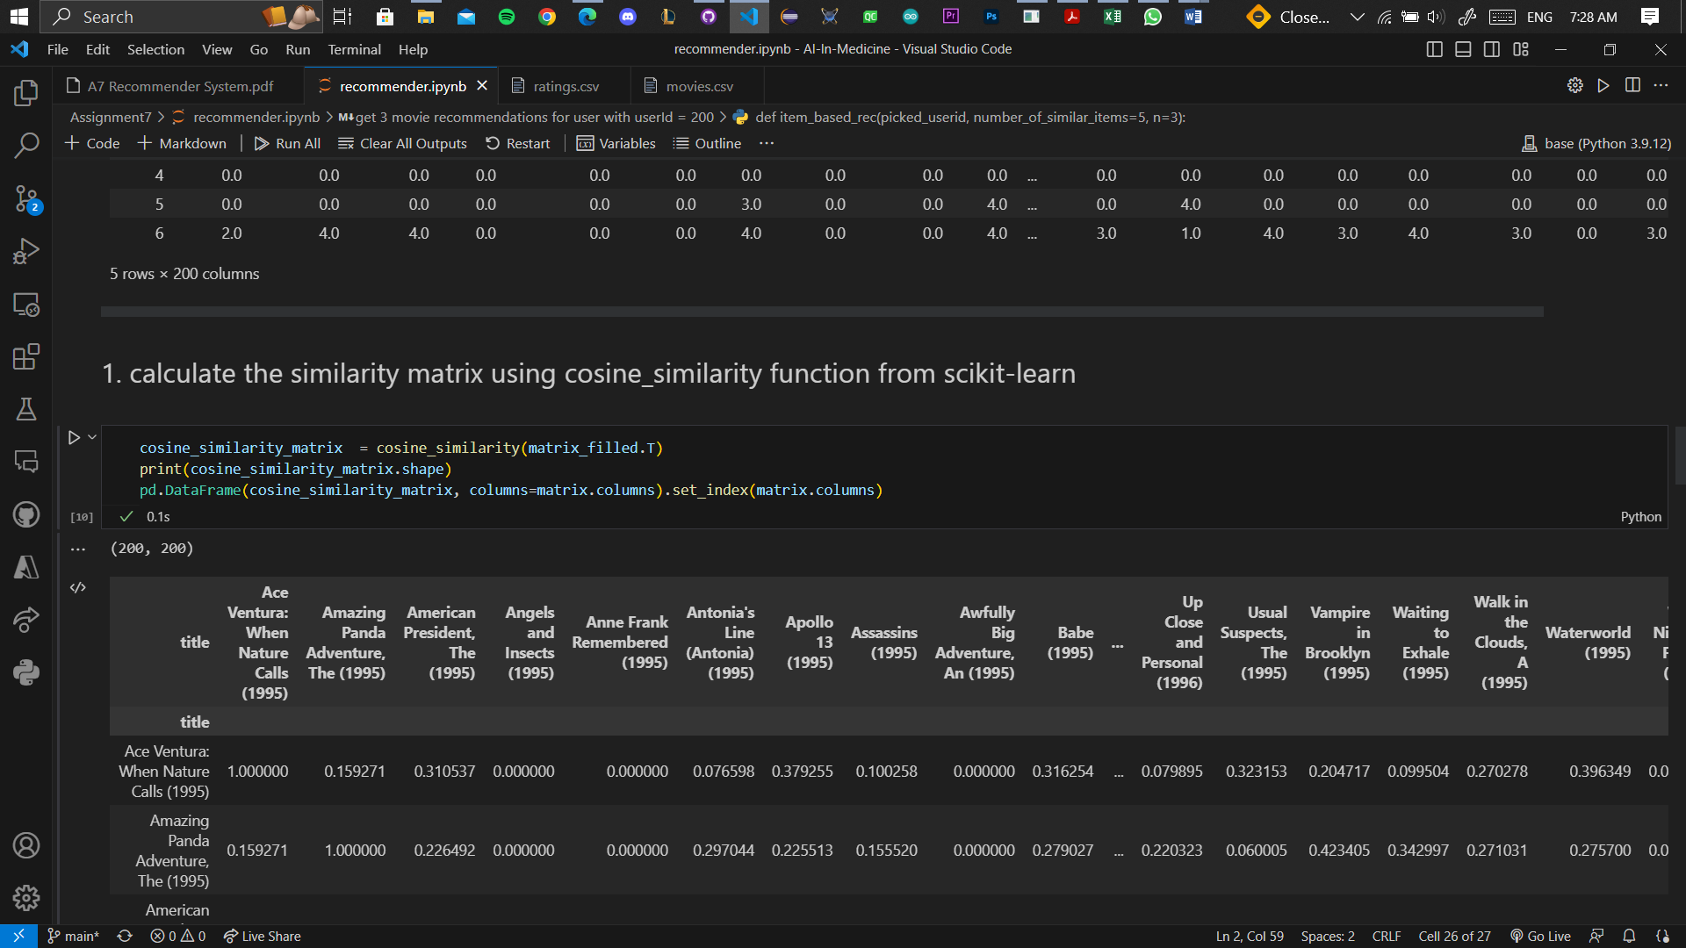I created the similarity matrix using cosine_similarity function from scikit-learn

# Get top ten similar movies to “Toy Story (1995)” and “Waiting to Exhale (1995)”.

* I defined top_10_similar_movies function

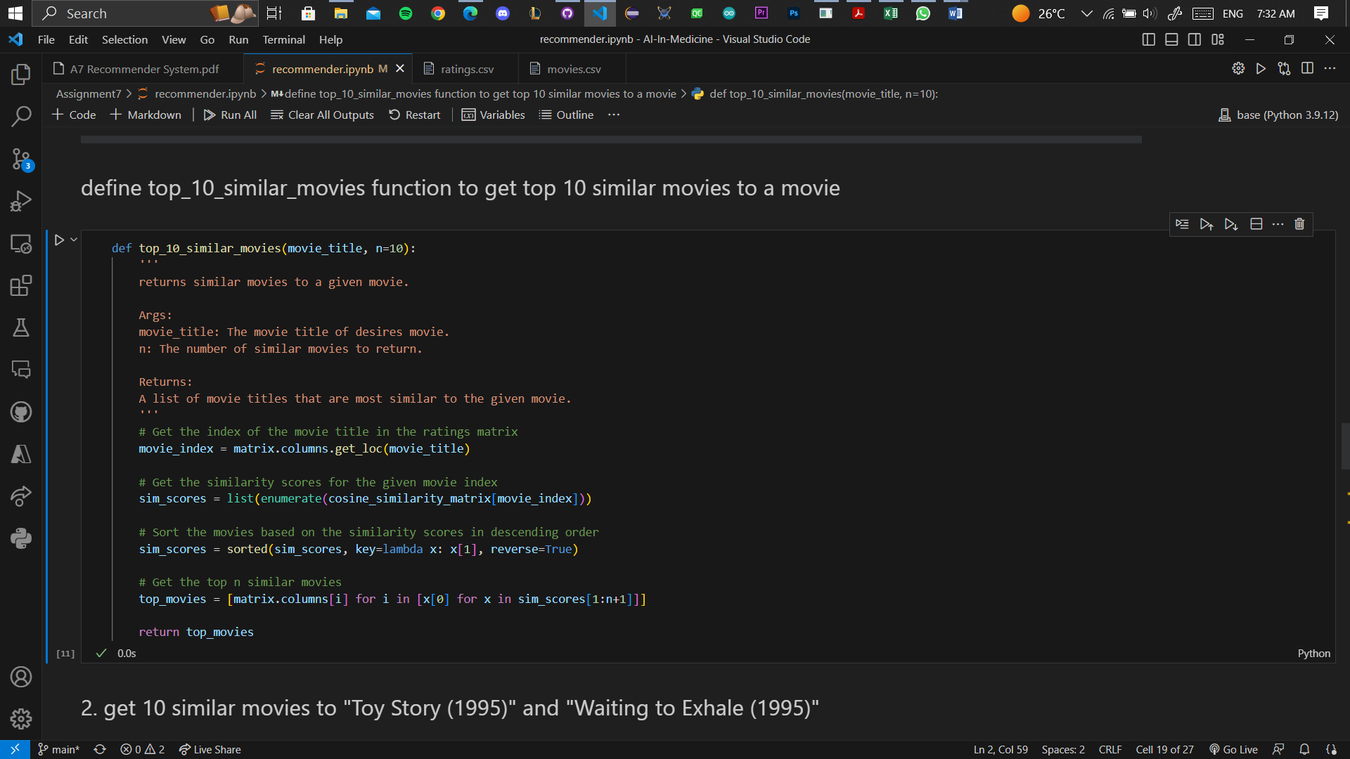

* I used the function to get similar movies to

“Toy Story (1995)” “Waiting to Exhale (1995)”

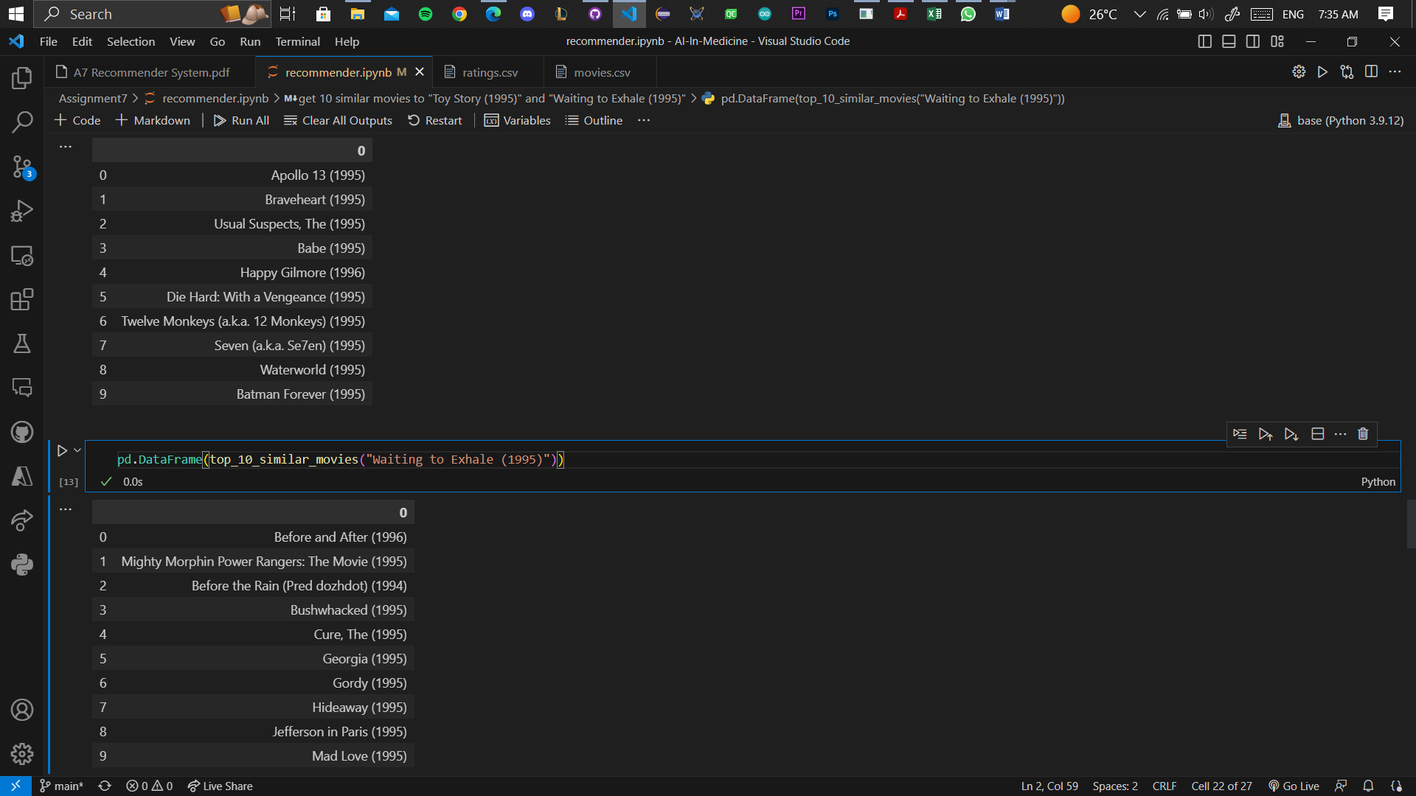

# Recommend three movies to user with userId 200

* 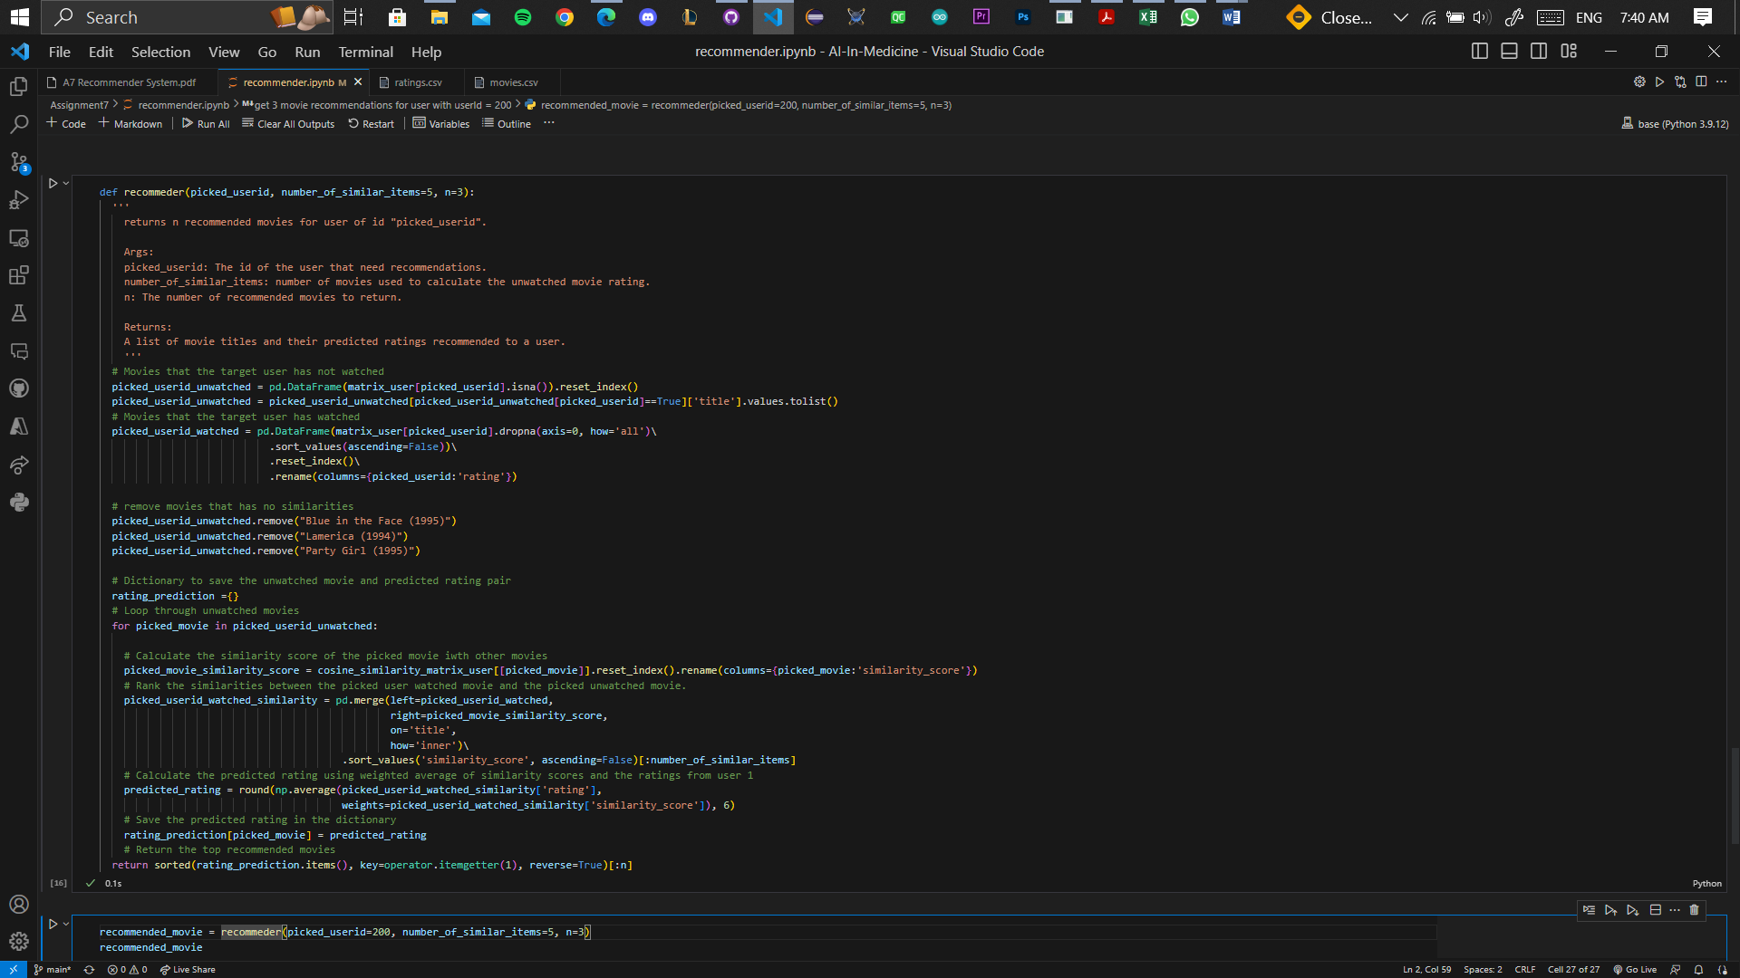I defined recommender function
* 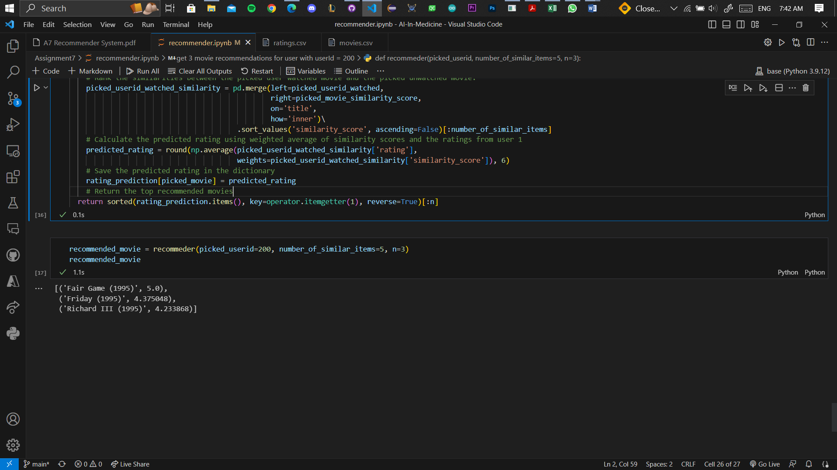I used the function to recommend 3 movies to user 200 based on movies he watched and their ratings.